Assignment #4

# Name: Muhammad Hussain Javed

# Roll Number: 21K-3584

Answer 1)

John’s Code:

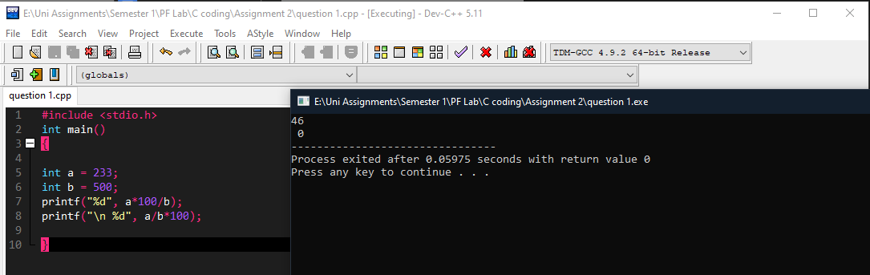

My corrections in John’s Code:

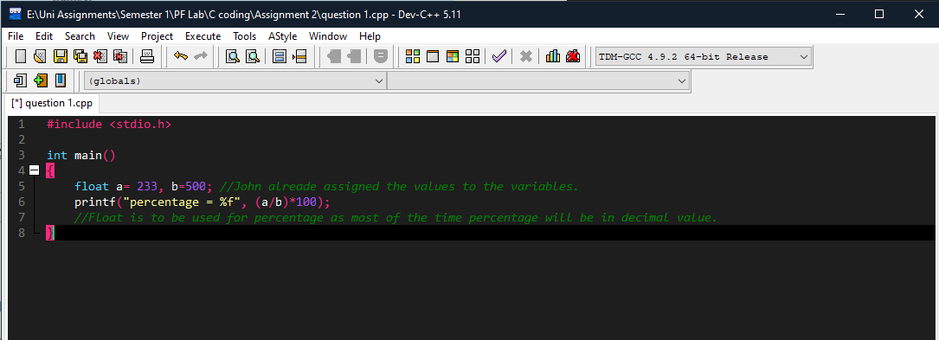

My Output:

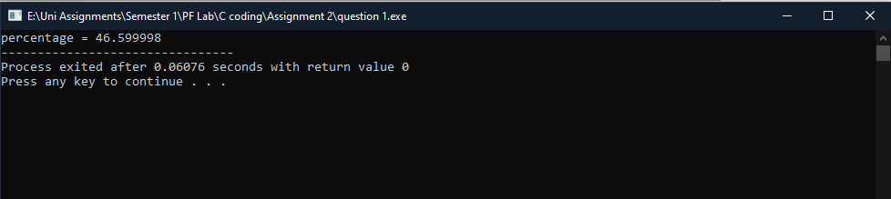

Answer 2)

Source Code:

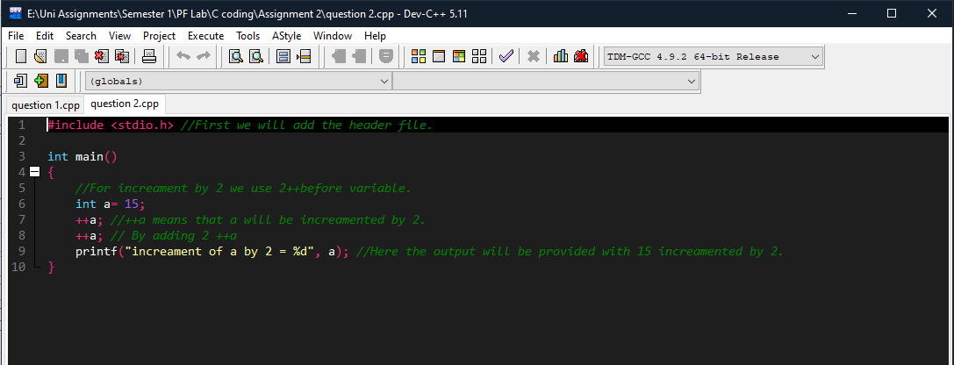

Output:

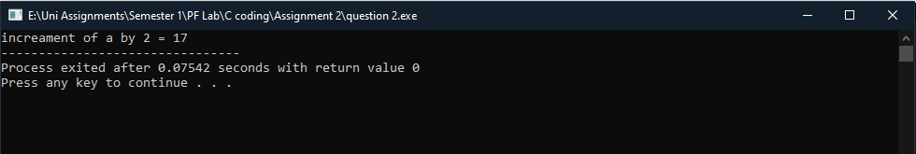

Answer 3)

Source Code:

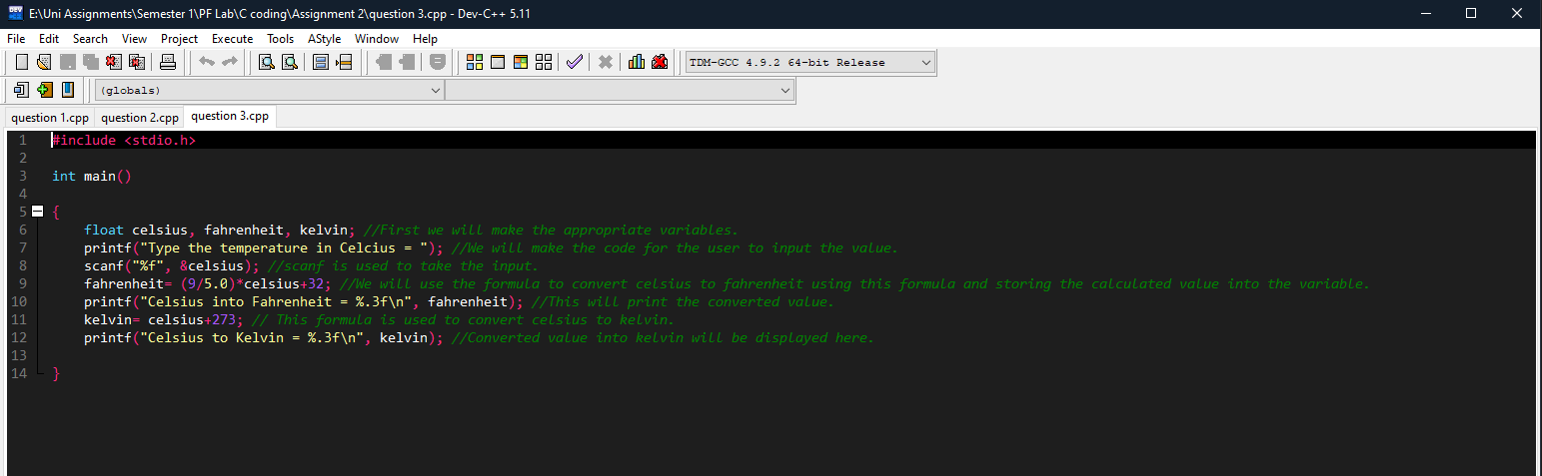

Output:

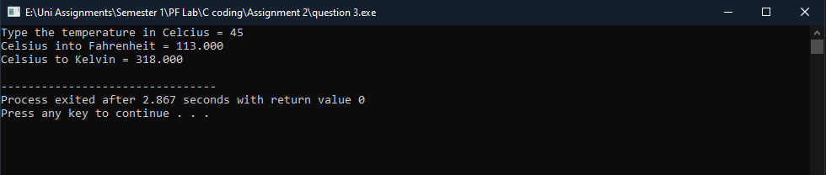

Answer 4)

Source Code:

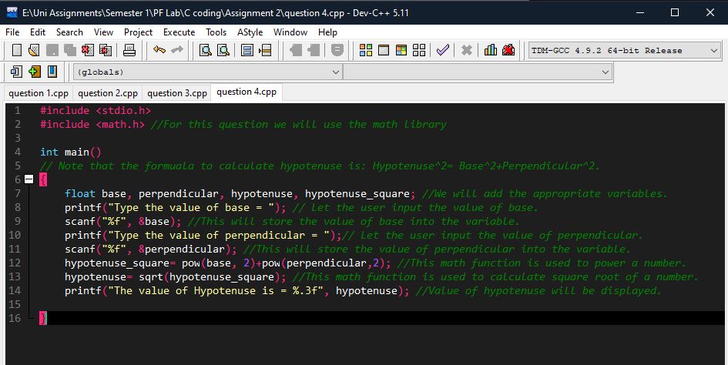

Output:

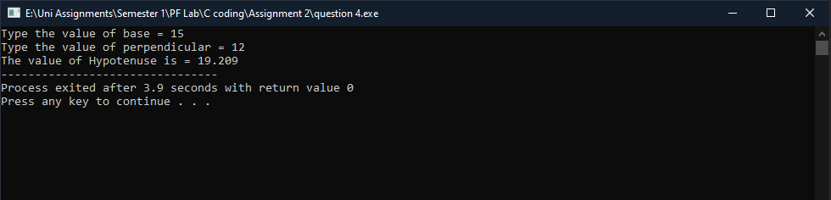

Answer 5)

In the above code, using float is the best choice as float has a lower bit size compared to double and because of that float will require less memory and less processing time compared to double. In programming we have make our code run as quick as possible, this is to save time, money, electricity/processing power.

Answer 6)

Source Code:

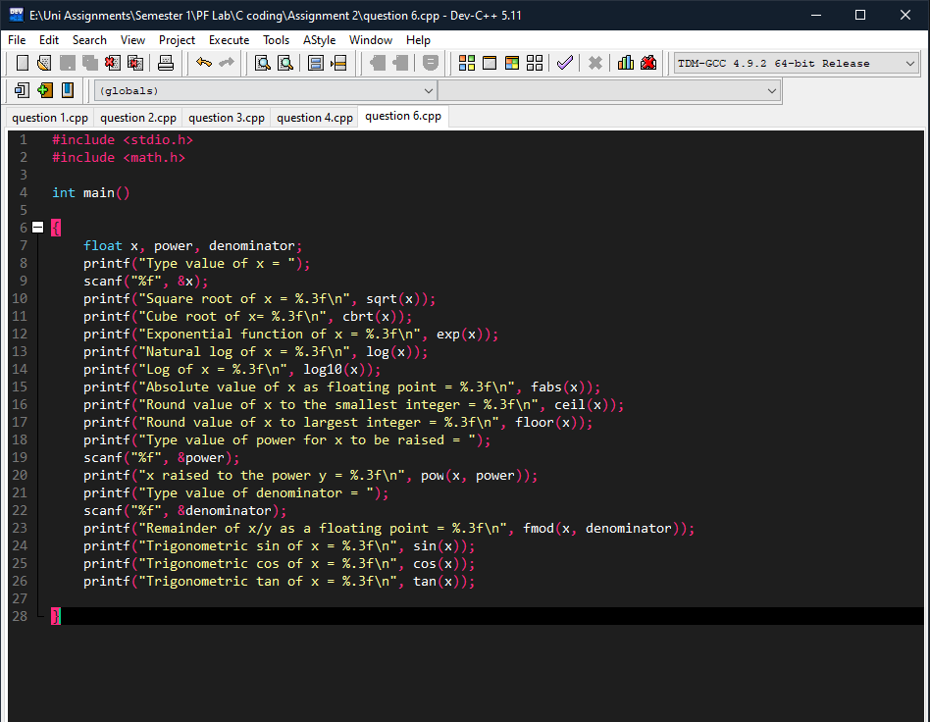

Output:

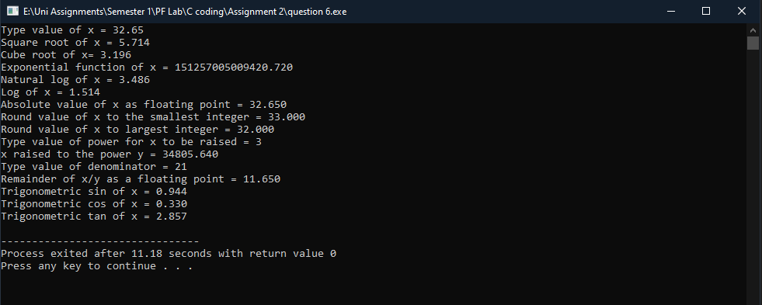

Answer 7)

Output of the source code in question:

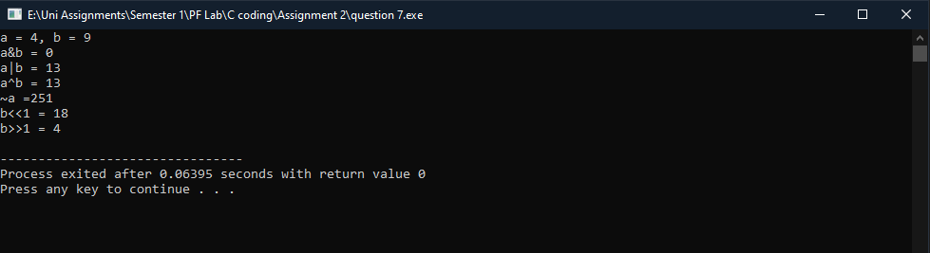

My source Code:

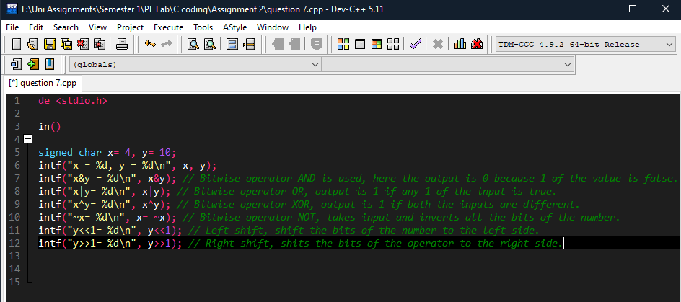

My Output: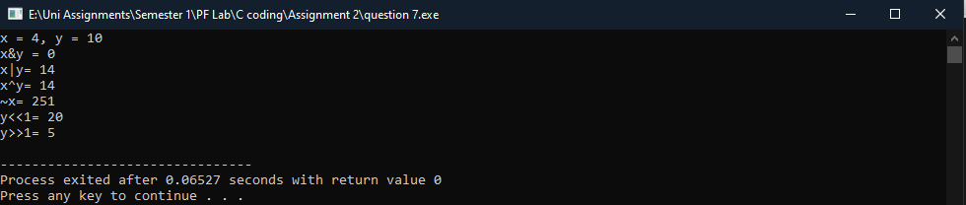

Answer 8)

Source Code:

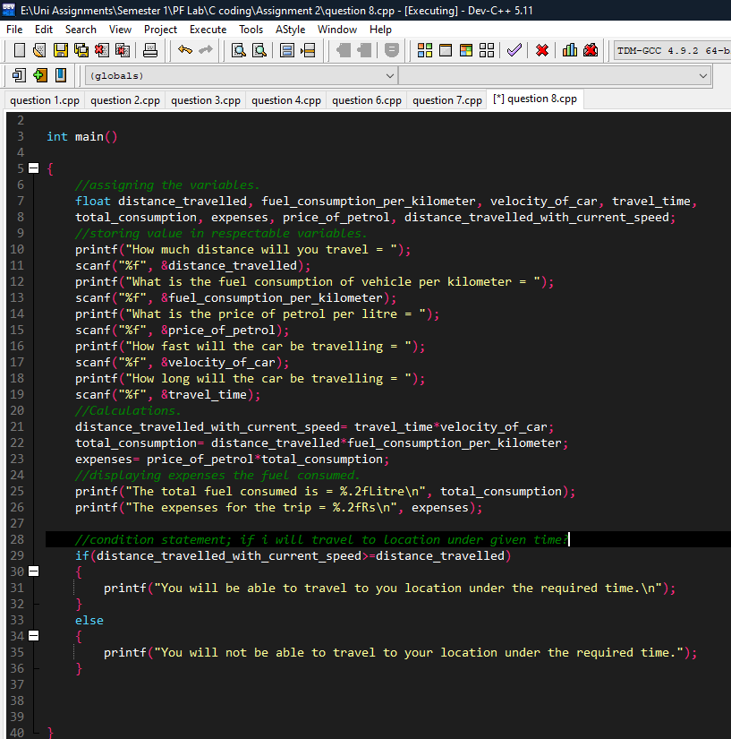

Output:

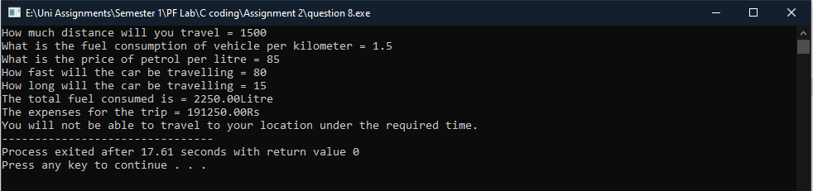

Answer 9)

Source Code:

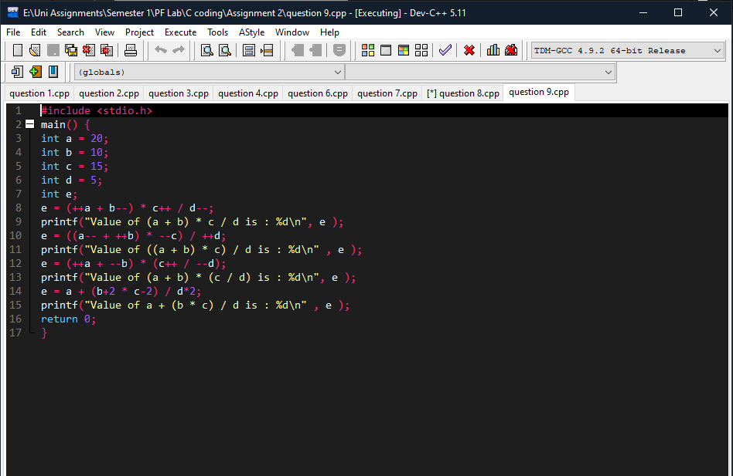

Output:

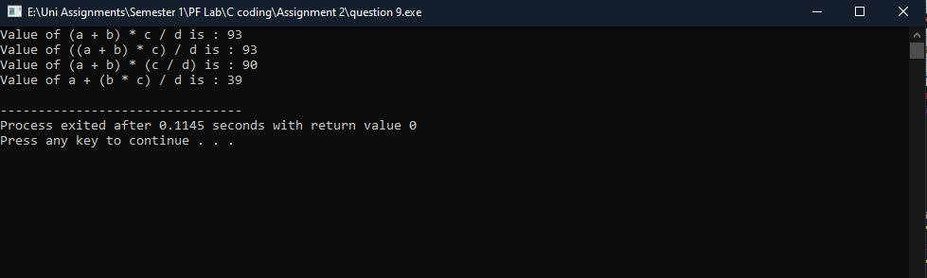

Explanation:

1. In the above output we can see that the division has higher association and precedence, because of that division is happening first. After that “c” is multiplied by the value of “a+b”. In the source code we can see in line 8 that a is being incremented by 1 because of prefix “++a”, while “b” is decrementing by 1 but the value of “b” printed will remain the same because of postfix “b++”. Value of “d” is also decrementing by 1 but the displayed value will be displayed the same i.e , 5.
2. In the second line of output we can see a math operation being performed by the dev. Here,   
   a=20 because of postfix but display value will be 21 because of prefix in line 1 of output;  
   b=10 because of decrement postfix in line 1 of output and increment prefix in line 2 of output.  
   c=15 because of increment postfix in line 1 of output and decrement prefix in line 2 of output.  
   d=5 because of decrement postfix in line 1 of output and increment prefix in line 2 of output.  
   After that the mathematical operation will continue giving the output = 93
3. In line 3 of output;  
   a= 21 because prefix in first line of code and decrement postfix in 2 line of code and then increment prefix in 3rd line of code.  
   b= 9 because of decrement postfix and then increment prefix in 2nd line of code and decrement prefix in 3rd line of code.  
   c= 15 because of postfix in 1st line of code and then decrement prefix in 2nd line of code and then increment postfix in 3rd line of code.  
   d= 4 because of decrement postfix in 1st line of code and then   
   increment prefix in 2nd line of code and then decrement prefix in 3rd line of code.  
   The mathematical operation will be performed and provide the value 90 because of integer syntax.
4. a= 21 because last value stored in variable is 21.  
   b= 9 because last value stored in variable is 9.  
   c= 15 because last value stored in variable is 15.  
   d= 4 because last value stored in variable is 4.

Answer 10)

Short-circuiting was understood sir, Thank you.

The following assignment was completed by “Muhammad Hussain Javed” of class BCY-1B.

Roll Number: 21K-3584.